

**Information for FACS Employers**

The [UGA Career Center](http://career.uga.edu/hireuga) is now using [Handshake](https://uga.joinhandshake.com/register), a free comprehensive resource that will allow you to advertise your open positions, connect with our students, register for career fairs, and schedule interviews. UGA students and alumni have exclusive access to Handshake to search for career, internship opportunities, and receive personalized recommendations based on their skill sets, strengths, and indicated interests.

**Please note:** After joining Handshake, creating your profile and connecting with your company, you’ll need to get permission to connect with UGA in order to begin the recruiting process.  To learn more read: [How do I search for schools and request approval?](https://joinhandshake.zendesk.com/hc/en-us/articles/221599447) As soon as you request approval, you’ll be placed in “Pending” status until UGA’s Career Center staff approves your request to connect.  While you’re in Pending status, you won’t yet be able to interact with students, post events, or create interview schedules. You are welcome to create a job posting, but you won’t actually be able to post it to UGA (and our students) until you are approved.  Employer requests are typically received within a couple of business days.

**Listing your job so that FACS students can see it:**

1. Try to create as descriptive a Job Title as possible – many students use this as their main search function. For example, if this is a Financial Planning position, please include Financial Planning in the position title.
2. In the Details section under Job Functions, select the function or functions most similar to your position.
3. Once you get to the Preferences Section of the job posting you will then see where you can select majors.
4. To select a major in FACS, choose the “click here” option at the bottom of the list that says “*These majors consolidate individual majors across every school on Handshake. To choose a specific major by individual school click here.*”

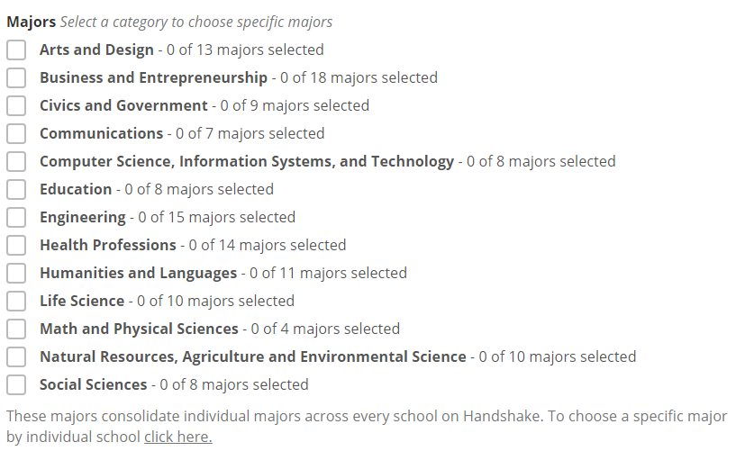

1. When you do so, search for and select “**University of Georgia**” as the school in order to see all of the majors offered at UGA. For a list of undergraduate programs in FACS, please visit <http://www.fcs.uga.edu/college/undergraduate-programs>. For M.S. programs, please visit <http://www.fcs.uga.edu/college/ms-programs>.

#### [FAQ’s about using Handshake](https://joinhandshake.zendesk.com/hc/en-us/categories/202707307-Employer)

#### [Learn more about posting jobs and internships](http://career.uga.edu/hireuga/post)

How to create your Handshake account:

